GSNmap report

Country name

2022-10-13

Contents of the summary:

* Specify the data products generated (mandatory & additional)

All national maps were generated following the Country guidelines and technical specifications for Global Soil Nutrient and Nutrient Budget Maps (GSNmap) – Phase I (FAO, 2022). All layers and accompanying standard deviation layers were created using a digital soil mapping approach based on the Quantile Regression Forest algorithm.

The following table (Table 1) summarizes the data points used for generating a national GSNmap product.

# Soil Attribute: Total Nitrogen

## Descriptive statistics of input data

Overview of the input data used for the Total Nitrogen soil property map

| mean | min | median | max | Number of points | Unit |
| --- | --- | --- | --- | --- | --- |
| 2342.1 | 938.2 | 2398.4 | 3378.1 | 119 | ppm |

## Resulting maps

### Predicted mean

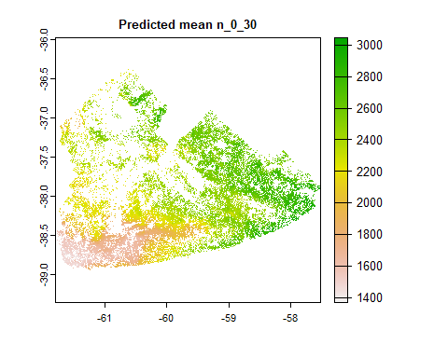

### Predicted standard deviation

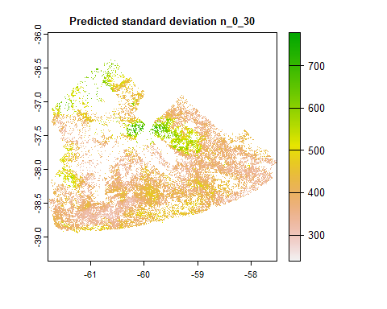

## Accuracy assessment

### Observed vs Predicted

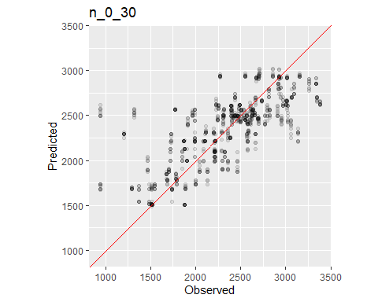

### Accuracy indicators

| ME | MAE | RMSE | r | r2 | MEC |
| --- | --- | --- | --- | --- | --- |
| -12.76 | 268.12 | 370.25 | 0.71 | 0.51 | 0.5 |

### Importance of covariates

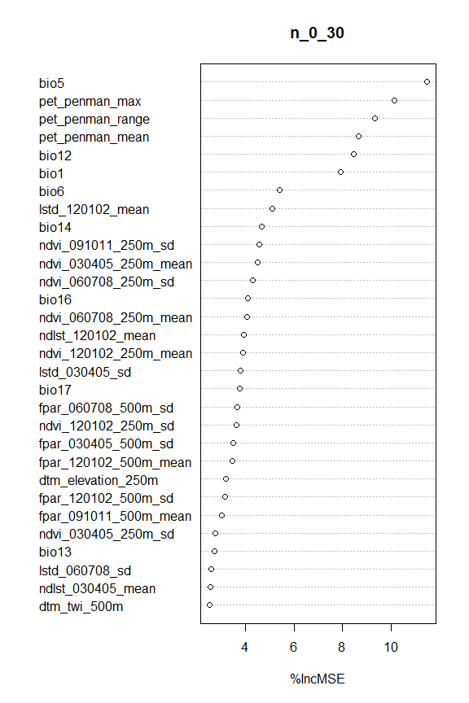

# Soil Attribute: Available Phosphorous (Bray)

## Descriptive statistics of input data

# References

*FAO.* 2022. Country guidelines and technical specifications for global soil nutrient and nutrient budget maps – GSNmap: Phase 1. Rome. <https://doi.org/10.4060/cc1717en>